NAGVA Board Call
Meeting Minutes: 08/09/2017

- Roll Call – Jason F, Brian C, Mark E, Lew S, Eric N, Jen C, Mark D, Andrew C, Jason P, Rich S, Brian S, Jimmy S
- Officer/Department Reports
  - President
  - Vice President
    - Working with Rick Talley to re-bid for 2019 Championships
  - Secretary
  - Treasurer
    - Still trying to close out Columbus Convention Center bills
    - Working on the NAGVA taxes
    - Financial Report - July
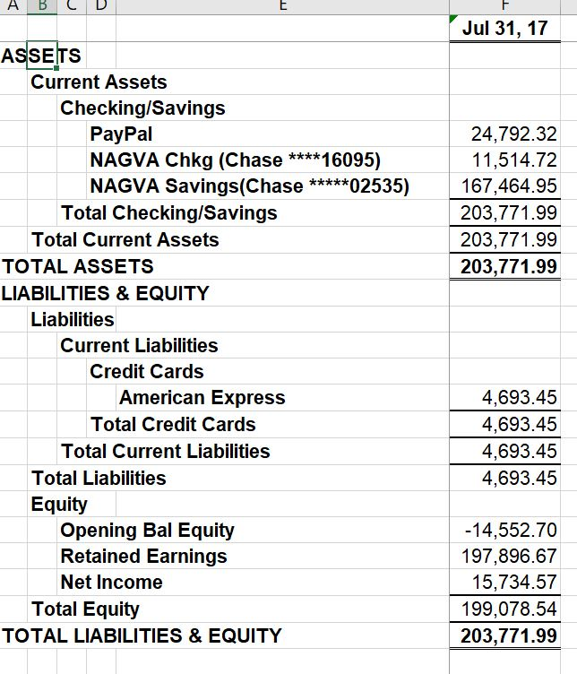
  - Registrar
    - Working on filling in missing DOBs – over 1000
  - Technology
  - Eligibility
    - July 2017
      - Medical Re-Rate: 8 received; 4 granted, 4 denied
      - 3 Year Inactive Re-Rate: 11 received; 10 granted, 1 denied
      - Grievances - 1 filed (multiple profiles/ratings); waiting on response from player (will rule against player if haven't heard from him by end of week).
  - Regions
    - Totals for July:
      - # of Tournaments: 4 - Chicago, San Fran, Austin, Atlanta
      - # of Teams: 206
      - # of NonRates: 286
      - # of Rerates: 66 (62% uprates, 10.6% downrates, 27% same)
      - Total # of RCs Utilized: 11, all out of region
      - (Chicago - 3, San Fran - 4, Austin - 3, Atlanta - 1)
  - Tournaments
    - Just received Puerto Rico’s sanction application
    - Working with Derek Saenz on the possibility of a West Coast tourney over Thanksgiving
    - Possible tournament in Charlotte in March
  - Officials
    - Revised R1 evaluation sheet is finished and will start being used immediately
    - Send complete and incomplete R1 eval forms to Officials
    - Working on editing the online R1 test
  - Communications
  - Canadian Representative
    - Holding first conference call with Canadian NAGVA Taskforce at the end of August
- MAL Reports
  - Trevor
  - Rich – Going to start working on a New Board member packet
  - Brian
  - Jimmy – Planning on attending a tournament that he’s not playing in and helping/learning from an RC
- MY Meeting Update
  - Hotel – Harrah’s New Orleans
  - Send/Make travel arrangements – Contact Lew
  - Send any dietary restriction to Brian C
- Championships Update
  - Local committee has already raised over $1800
  - Running a grass tourney this month
  - Reaching out to local bars for donations and the possibility of hosting events
- New Business
  - Bruce Ingersoll’s Appeal
  - Discussion: Board felt that there wasn’t enough proof to suspend the players for a year.
  - Vote: 6 nays – deny the appeal, 6 - abstentions
- Meeting Adjourns

